
Version 2.0
Quick Start Guide

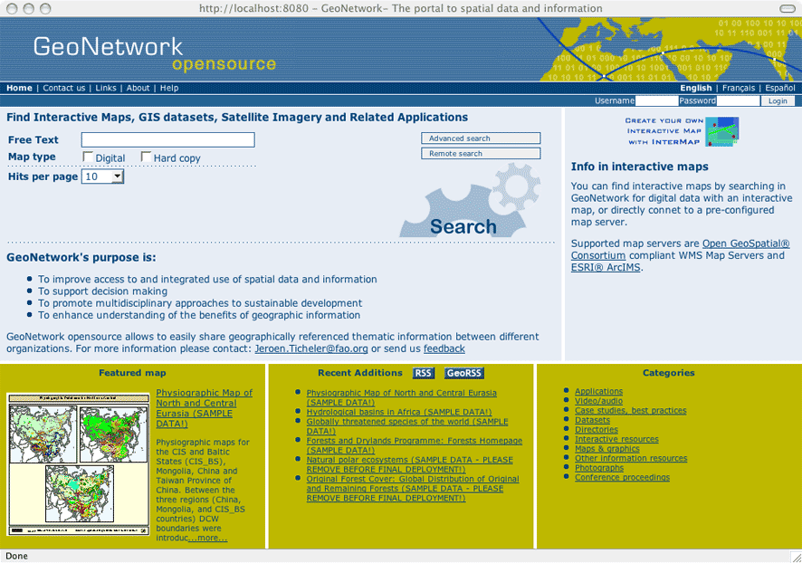

Contributed by
UN-OCHA

Quick Start Guide – GeoNetwork opensource Version 2.0

Edition: 1st Edition. GeoNetwork opensource revision
Author: Lale Yurtseven
Contributing Editors: Patrizia Monteduro (FAO-UN), Paolo Palmero, Paola Desalvo (WFP-UN), Jeroen Ticheler (FAO-UN)
Team Coordinator: Suha Ulgen
Published by: United Nations - OCHA - Office for the Coordination of Humanitarian Affairs
Advocacy and Information Management Branch, United Nations
First Publishing Date: 23 February 2006
Revision date: 10 April 2006
Contact Information: United Nations - OCHA - Office for the Coordination of Humanitarian Affairs
One UN Plaza, DC1-1360, New York, NY 10017
Telephone: +1(917)367-9005
Web Site: www.un.org
Copyright © 2006 United Nations

Table of Contents
Table of Contents i
1 - Introduction 1
2 - Getting Started 2
2 – Searching for Maps and Data 3
2.1 - Searching List of Maps 3
2.2 - Simple Search 3
2.3 - Advanced Search 4
2.4 – Remote Search 5
2.5 Analyzing Search Results 6
3 – Viewing and Analyzing the Data 8
3.1 Switching from Default to Advanced to XML View 8
3.2 - Meta Data Description 8
3.2.1 - Identification Section 9
3.2.2 - Geographic Section 11
3.2.3 - Distribution Section 12
3.2.4 - Reference System Section 13
3.2.5 - Data Quality Section 14
3.2.6 - Metadata Information Section 14
4 – Adding New Maps and Metadata 15
4.1 Creating a New Record 15
4.1.1 - The Default and Advanced View 15
4.2 Entering Metadata for your Map 16
4.2.1 Using basic commands of the editor 16
4.2.2 - Entering Metadata For Your Map 16
4.2.3 - Creating a Thumbnail 17
4.2.4 - Assigning Privileges for a Map 19
4.2.5 - Assigning Categories for a Map 20
Appendix A – Glossary of Data Field Descriptions 23

1 - Introduction
GeoNetwork opensource is a standards based and decentralized spatial information management environment, designed to enable access to geo-referenced databases, cartographic products and related metadata from a variety of sources, enhancing the spatial information exchange and sharing between organizations and their audience, using the power of the Internet. This approach of geographic information management provides a wide community of spatial information users with easy and timely access to available spatial data and to existing thematic maps that support informed decision making.
The main goal of the GeoNetwork opensource software is to improve the accessibility of a wide variety of data, together with the associated information, at different scale and from multidisciplinary sources, organized and documented in a standard and consistent way.
The term data in this application refers to datasets, maps, tables, documents, etc. that are linked to the metadata of a specific record.

2 - Getting Started
You can find the GeoNetwork opensource software through the Internet at the GeoNetwork opensource Community website: http://geonetwork.sourceforge.net.
There are no requirements for general visitors to search and access information in a GeoNetwork opensource based catalog. To get access to advanced features, you need an account to log in, A username and password should be provided by the GeoNetwork opensource system administrator. Depending on your privileges, you will be able to see, submit and edit metadata records. Each user is assigned to a particular work group and is able to access data within that work group.
To log on, simply go to the homepage as listed above and at the top right corner of the page, enter your username and password, then click the login button. (See figure 2)
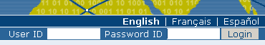
Figure 2

2 – Searching for Maps and Data
There are different ways to search the database for maps and other geographic data. This guide will introduce you to the most commonly used searches: Accessing a list of geographic information through your home page, simple and advanced searches. Whichever search you choose, remember that you will see results based on your privileges and assigned work group.

2.1 - Searching List of Maps
To search lists of maps, from the home page, under the Categories on the bottom right of the screen, click on Maps and Graphics. A list of Maps that are within your work group will be displayed. To view details of a map, please click on the map name you wish to review.

2.2 - Simple Search
The simple search allows you to search text within the entire record, such as keywords of the metadata.
- From the home page, enter a search term or letter(s) in the Free Text field. You can use one or more thematic keyword(s) or strings in quotes. Keywords and operators (and, or, not) are not case sensitive. (See figure 2.2 a).
- You can search for Digital or Hard Copy maps. To search one or the other, simply check the box next to the one you wish to search. If no box is checked, all maps will be searched.
- You can customize the number of output results per page in the Hits Per Page field. Simply highlight the number of records to be displayed or leave it on the default number (10).
- Click the Search button. (Figure 2.2 b)
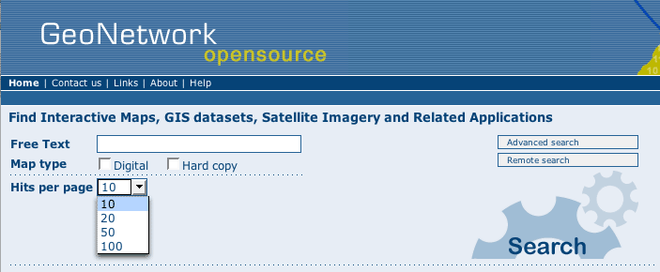Figure 2.2 a

Figure 2.2 b

2.3 - Advanced Search
The advanced search option works similar to the simple search, however, you can be more specific in your search criteria. Here you can also search directly in the title or abstract fields and add more keywords to customize your search further. You can also specify the geographic location of your search.
To conduct an Advanced Search, from the home page, click on Advanced Search (see figure 2.2 from the simple search section). Then fill out the following page with the information listed below (Figure 2.3):
- Although it is strongly suggested that you use the Free Text Field, you can enter information in one or multiple field(s).
- To search by Title, Abstract, Free Text, or Keyword(s) type any text into the respective field. You can use one or more field. If you do not want to search by a given field, simply leave that field blank.
- In the location field, you can choose from different options: is, overlaps, encloses, is fully outside. If you use this field, be cautious as this limits your output data as follows:
  - If you choose Location is Country, only maps for the entire country will show. In other words, a city map within that country will not show in the output results.
  - Similarly, if you choose other criteria, such as overlaps, encloses or is fully outside a location, only maps within the exact given criteria will show in the output results.
- You can choose the Group you wish to search in. If you choose a work group, only results within that Group will show. Click on the Work Group Field and a drop-down list of work groups that you can search in will appear. Choose the one you wish to search in by highlighting it. Or simply leave keep Any selected to search all groups.
- You can search for maps by Category, such as Maps and Graphics, Applications, etc. It is suggested to leave this field in Any Category. However, if you need to search by a specific category, simply highlight the category you wish to search from the drop-down list.
- You can search for maps by Site. Simply highlight the Site you wish to specify or just keep Any selected to search all sites. Site based searches will replace the Remote Search ultimately as they are more reliable and faster.
- You can search for Digital or Hard Copy content. To search one or the other, simply check the box next to the one you wish to search. If no box is checked, all content will be searched.
- You can customize the number of output results per page in the Hits Per Page field. Simply highlight the number of records to be displayed or leave it on the default number (10).
- Click the Search button.
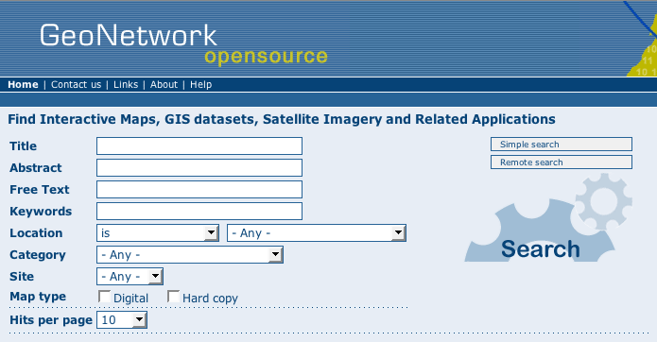
Figure 2.3

2.4 – Remote Search
Through the distributed/remote search tool GeoNetwork opensource allows you to search external geographic metadata catalogs in different catalog servers that are using the same standard protocol (Z39.50).
The same principles of the local search apply to the distributed search with the only differences being the multiple selections of the servers you want to target and the timeout that you assign. The timeout field determines how much time you want to allow connecting to the remote server. If the server does not respond within the given time period, further attempts to connect will be terminated. It is suggested that you choose the maximum timeout period of 30 seconds to allow more time to connect. (See figure 2.4)
To conduct a Remote Search, from the home page, click on Remote Search (see figure 2.2 from the simple search section). Then fill out the following page with the information listed below (Figure 2.4):
- Type any keyword(s) in the text field.
- Choose the Profile you wish to use for this search by selecting it from the drop down list.
- Choose the server(s) you want to conduct your search on. Simply select the server(s) for your search. For multiple selections, hold down the control key and select by clicking on the servers to be selected.
- Specify the Timeout for your search. It is recommended that you select the maximum of 30 seconds.
- You can search for Digital or Hard Copy maps. To search one or the other, simply check the box next to the one you wish to search. If no box is checked, all maps will be searched.
- You can customize the number of output results per page in the Hits Per Page field. Simply highlight the number of records to be displayed or leave it on the default number (10).
- Click the Search button.
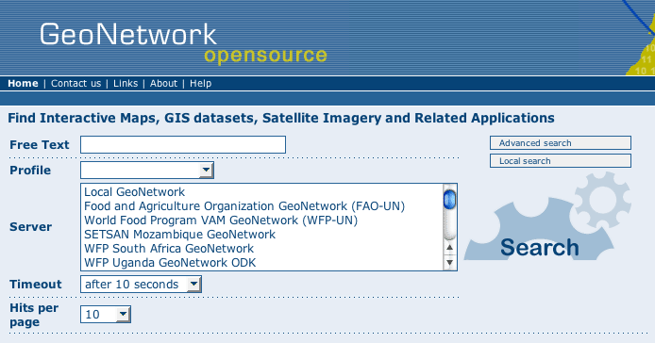
Figure 2.4
The output results of the remote search will include all the relevant metadata that are within all partners interoperable systems including all GeoNetwork opensource nodes around the world.

2.5 Analyzing Search Results
The output of the search provides you a list of the metadata records that should fit your request. For each metadata the result page shows the title, a hint of the abstract, keywords and, as is shown below, four sections to be consulted. (See figure 2.5)
- Metadata: The metadata section that properly describes the dataset (e.g.: citation, data owner, temporal/spatial/methodological information) and that eventually contains links to other web sites that could provide further information about the dataset.
- Download: Depending on the privileges that have been set for each record, when this button is present, the dataset is available and downloadable. The downloadable package is in Zip (compressed) format and contains the dataset in GIS Files (vector/raster, tiff, etc.) with a legend and a map image. The process for retrieving data is simple and quick by just clicking the download button (fig.2.5 a) or by using the proper link in the specific metadata section for distribution info (fig.2.5 b). All datasets that you can access from GeoNetwork are public domain and free of cost.

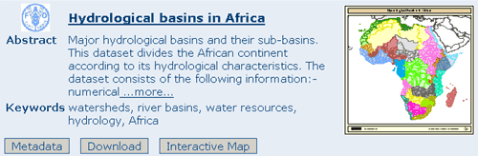
Figure 2.5 a
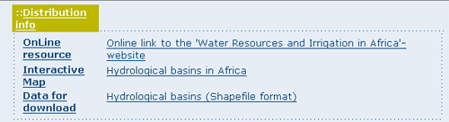
Figure 2.5 b
- Interactive Map: The map service is also optional. When this button is shown, an interactive map for this layer is available. Interactive maps will by default be displayed in a separate window through the InterMap map viewer.
- Graphic Overviews: They are small and large overviews of the map used to properly evaluate usefulness of the data. Simply click on the small image to enlarge it. (Figure 2.5)
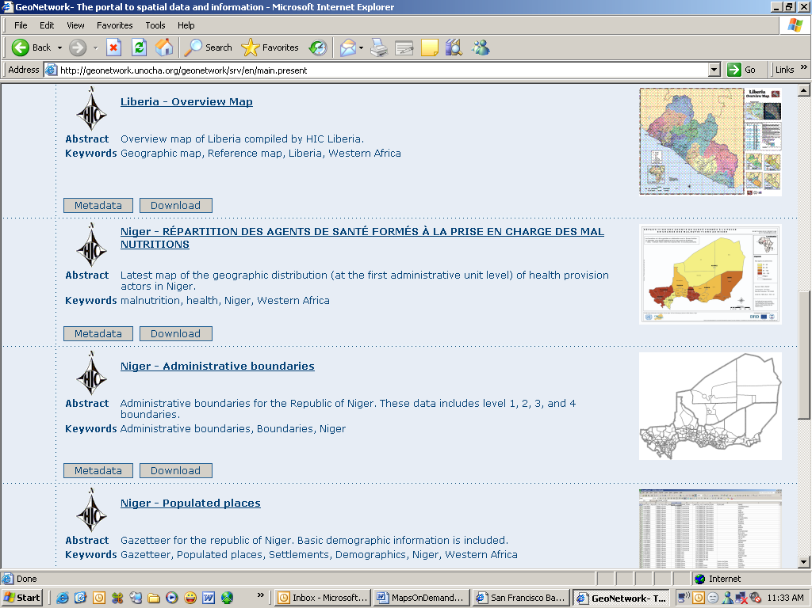
Figure 2.5

3 – Viewing and Analyzing the Data
Once you have completed your search, you view details of a particular record by clicking on the name of the data description.

3.1 Switching from Default to Advanced to XML View
Once you bring up a particular record, you can choose between Default, Advanced or XML View. To switch view, simply click on Default View, Advanced View or XML View on the left column of the page. The view in bold is the view you are currently in. (See figure 3.1)
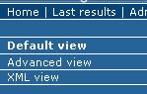
Figure 3.1
The Default View shows a selection of the main fields from different categories in one single view. This facilitates both the user and the editor in reading and editing a metadata record. The default view is illustrated and described below.
In the Advanced View, the ISO profile offers the possibility to visualize and edit the entire metadata structure organized in sections accessible through tabs on the left column. Each section is composed of mandatory and optional metadata elements, those that are mandatory are indicated with the symbol (M). You can use this view to write more advanced metadata descriptions or templates.
The XML View shows the entire content of the metadata in the original hierarchical structure; different colors allow distinguishing between an element's name and its value.

3.2 - Meta Data Description
The metadata profile used by GeoNetwork opensource to describe the geographic data and services is based on the ISO standard 19115:2003 that provides information related to the identification, the spatial and temporal extent, spatial reference, the quality, and distribution of a geographic dataset. (See figure 3.2)
GeoNetwork opensource provides a set of simplified metadata templates that hide the complexity of the ISO 19115 standard. These can be used as a basis for describing geographic metadata and they are extendable with new elements to fit specialized needs through the Advanced View.
The main metadata sections used are the: Identification Section, Distribution Section, Reference System Section, Data Quality Section and Metadata Section. For the purpose of this Quick Start Guide, these are the sections that are described here.
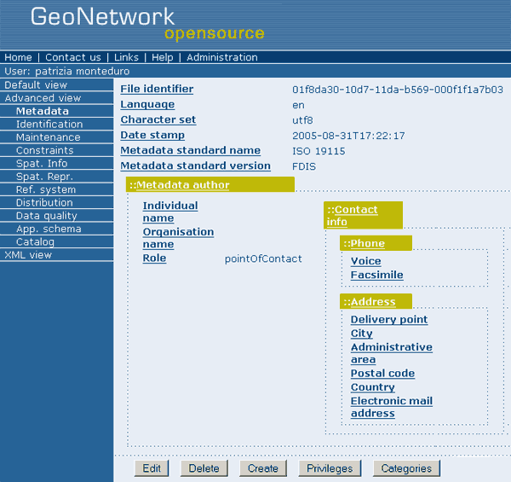
Figure 3.2

3.2.1 - Identification Section
This section includes information about the citation of the resource (title, date of creation or publication, edition, presentation form), the abstract, the purpose, any supplemental information, the status, topic category and keywords. It also contains the spatial representation information like the data type, the scale, and the graphic overview metadata elements that allow the creation of a link between the metadata and the data graphic representation (figure 3.2.1 a).
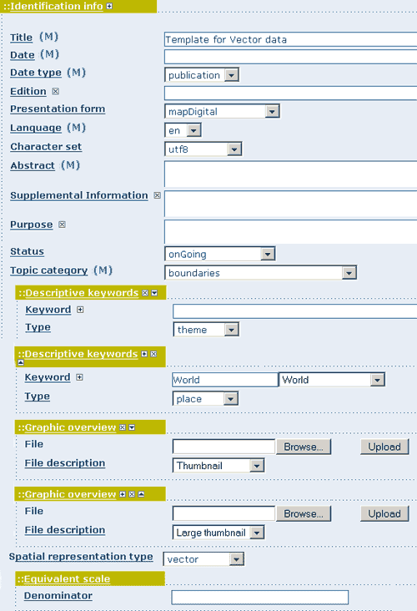
Figure 3.2.1 a
The spatial and temporal extent (minimum bounding box within which the data is available and temporal range of the data validity) are also included in this section in addition to elements for describing restrictions on data access, use and data maintenance (figure 3.2.1 b).
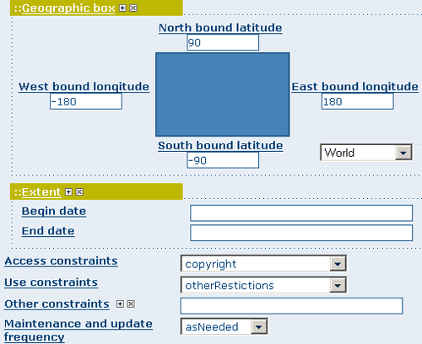
Figure 3.2.1 b
Finally, the Identification Section provides information about the person or organization responsible for the data and who is considered to be a point of contact for the resource i.e. the dataset owner, originator, distributor, publisher, etc. (3.2.1 c).
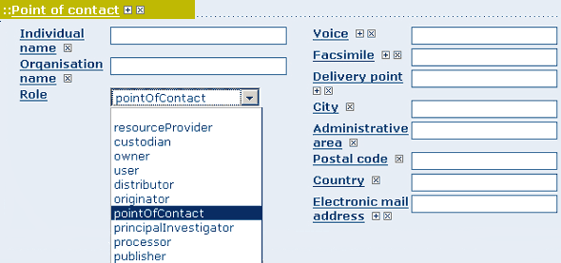
Figure 3.2.1 c

3.2.2 - Geographic Section
Through the elements below you will describe the mechanism used to represent the geographic information of the resource (vector, raster, text table, etc.), the scale and the spatial and temporal extent; the spatial extent is represented by the minimum bounding box within which the data is available. The temporal extent is described by the starting and ending date of the validity period. Make sure you use degrees as the unit for the geographic coordinates as they are the basis for the geographic searches (Figure 3.2.2)
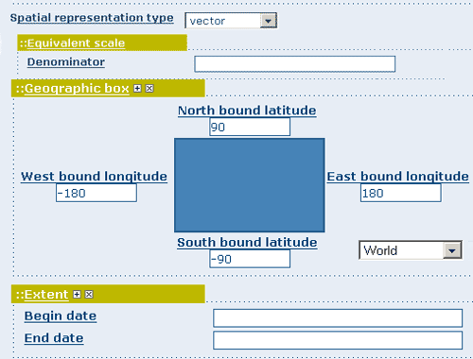
Figure 3.2.2

3.2.3 - Distribution Section
This section provides metadata elements for accessing other useful on-line resources available through the web. The distribution elements allow for on-line access using an URL address or similar addressing scheme and provide the protocol for the proper connection for accessing geographic data or any other types of digital documents using the download function. Furthermore through the on line resource it is possible to link a metadata with a predefined map service and see that map interactively (figure 3.2.3).
Additionally, you can upload a dataset stored on your local computer. Files in whatever format can be uploaded: doc, PDF, images, GIS layers, etc. For the latter the distribution in a compressed (ZIP) file is recommended. You can include the GIS data, the legend, documentation that can help the interpretation of the data, related reports, detailed descriptions of the data processing, base data used to create the dataset specified and/or other relevant information. Follow these guidelines for uploading datasets:
- Make sure the total size of the compressed file is reasonable (less than 50 MB). In cases your data is bigger than 50MB, consider a different mechanism to serve this data, e.g. through an FTP or HTTP server and than link the resource through an online resource ‘Web address (URL)’.
- You can create several smaller files when appropriate and upload them sequentially.
- You add the size of the file at the end of the description field.

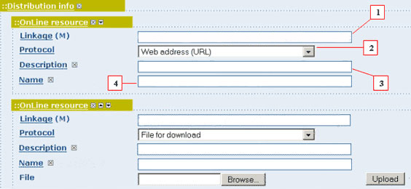
Figure 3.2.3
To Upload a Dataset, follow these steps:
- The linkage field can be left empty when uploading a file. The system will automatically fill out this field.
- Select the correct protocol to be used. If you do not see an upload button when File for download is selected, Save the metadata and return to the upload section. A Browse button should appear.
- Provide a short description of the data.
- The Name filed can be left empty. It will be filled automatically during the upload with the name of the file.
- Click the Browse button and navigate to the folder where the file to be released is stored. Decide if you want to upload multiple files as one unique zip file or as multiple separate downloads. It is a good idea to add additional documentation with GIS data sets that provide the user with information related to the data described. Note: the size of a single file to upload can not exceed 50 Mbytes.
- Click Upload and then Save.

3.2.4 - Reference System Section
The Spatial Reference System section defines metadata required to describe the spatial reference system of a dataset. It contains one element to identify the name of the reference system used (figure 3.2.4). Using elements from the advanced form, this section may be modified to provide more details on data projection, ellipsoid and datum. Note that if this information is provided, a reference system identifier is not mandatory.
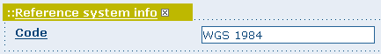
Figure 3.2.4

3.2.5 - Data Quality Section
The Data Quality section provides a general assessment of the quality of the data. It can describe the different hierarchical levels of data quality, namely a dataset series, dataset, features, attributes, etc. This section also contains information about the sources of the input data, a statement that provides a general explanation on the production processes (lineage) used for creating the data (figure 3.2.5). The statement element is mandatory if the hierarchical level element is equal to ‘dataset’ or ‘series’. Detailed information on completeness, logical consistency and positional, thematic and temporal accuracy may be directly added through the advanced form.
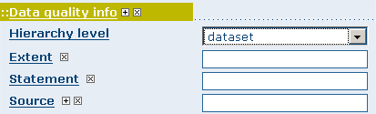
Figure 3.2.5

3.2.6 - Metadata Information Section
This section contains information about the metadata itself: the Global Unique Identifier (GUID) assigned to the record (this is the ‘File identifier’), language and character set used, date of last edit (‘Date stamp’) and the metadata standard and version name of the record (figure 3.2.6 a).
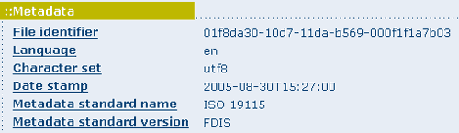
Figure 3.2.6 a
It also contains information on the metadata author responsible for the metadata record; this person can also be a point of contact for the resource described (figure 3.2.6 b). Information on the Metadata author is mandatory.
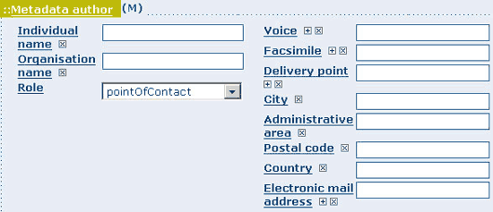
Figure 3.2.6 b

4 – Adding New Maps and Metadata
This section leads you through the process of adding new record (new maps with metadata). You will use the template system, add thumbnails, upload data, link to services and set access privileges to the metadata and data.
To add or edit maps and metadata, you must be registered as an Editor into the work group you want to add records to. Contact your administrator if you are not a registered Editor for your work group. To add a new record using the online editor, always provide as much data as possible. In addition to the mandatory fields (See Glossary Section of this guide), we recommend you do fill out these critical fields if you have the information available:
Title - Abstract - Presentation Form - Keyword - Type - Denominator - Geographic Selection - Access Constraint - Point of Contact - Distribution Info - Online Resources - Author - Reference System Info
You will also create a thumbnail for your map that is required to be displayed in search results.

4.1 Creating a New Record
- From the home page, click on the Administration Tab on to top.
- Select New Metadata from the List of the admin page.
- Select the metadata standard Template, if possible, use the preferred one. (Figure 4.1) GeoNetwork opensource comes by default with support for three metadata standards, ISO19115, FGDC and Dublin core. For the ISO standard, two templates have been developed; one for vector and one for raster data. Both contain a relevant set of elements to describe the respective types of data. More templates can be developed online.
- Select the Group the metadata will belong to. These are the groups you are authorized to add metadata to by your administrator.
- Click on Create.
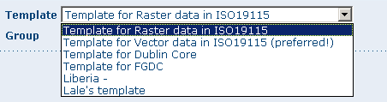
Figure 4.1

4.1.1 - The Default and Advanced View
GeoNetwork opensource allows you to view and edit metadata using a default view or an advanced view. To switch views, simply click on the view you want to switch to on the viewing options on the left. (See figure 4.1.1)
The Default View is the preferred view because it shows a selection of the available metadata elements and hides the complexity of the full metadata standard.
However, if there is a need to add or remove metadata elements, you can switch to the Advanced View at any time while editing. For the ISO metadata standard, the advanced form provides access to the full set of ISO elements. To reduce its complexity, the display of the advanced form is divided into different pages, accessed through tabs that allow you to see the different categories of information. The advanced view shows buttons that let the user insert or remove new elements. The new elements will then be visible in the default view.
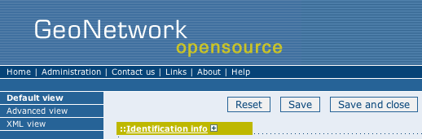
Figure 4.1.1

4.2 Entering Metadata for your Map
As we suggest some required and useful fields for the metadata for a map, you should gather as much information as possible to properly identify and understand the map’s resource and characteristics you want to describe. Use the default view to start. If necessary, you can always switch to advanced view or come back later and edit the record in advanced view.
Note that the fields marked with an [M] in the glossary are mandatory. The standard definition for each field can be read by right clicking on the element name. In addition to the mandatory fields (See Glossary Section of this guide, Appendix A), we recommend you do fill out these critical fields if you have the information available:
Title - Abstract - Presentation Form - Keyword - Type - Denominator - Geographic Selection - Access Constraint - Point of Contact - Distribution Info - Online Resources - Author - Reference System Info

4.2.1 Using basic commands of the editor
Fields are either free text fields or drop down lists. Free text means you can type any text into that field. Drop down lists allow you to select from the list.
You can also add multiple fields of the same kind by clicking on the + symbol next to the field. Or you can delete it by clicking on the x symbol next to the field. One example to add the field would be if you want to add a date. You might want to enter the publication and revision date for a map.

4.2.2 - Entering Metadata For Your Map
Please Follow these steps to enter metadata for your map: For the purpose of this guide, we will only go through the fields that have been identified as critical to enter. However, the concept for all fields is the same. To view descriptions of the other fields, please refer to the Glossary in Appendix A of this guide.
Title: Under the Identification Info field, give your map a name. There will be a default name which is the template name. Use free text to describe your map here.
Presentation Form: Specify the type of presentation, i.e. digital, hard copy, table, etc.
Abstract: Enter a paragraph describing the map.
Descriptive Keywords: Enter Key words that describe your map. Also specify the type of keyword you are entering, i.e. place, theme, etc. Remember that you can add another keyword field if you need to add different types of keywords.
Denominator: Enter the denominator for an equivalent scale of a hard copy of the map.
Geographic Box: Enter the longitude and latitude for the map and select either the country of the world map criteria.
Access Constraints: Enter an access constraint here, such as a copyright, trademark, etc. to assure the protection of privacy and intellectual property.
User Constraints: Enter a user constraint here to assure the protection of privacy and intellectual property.
Other Constraints: Enter other constraint here to assure the protection of privacy and intellectual property.
Point of Contact: Enter all mandatory and other information you have on hand for the contact of the person(s) associated with this resources of the map. Note that some fields are only conditionally mandatory, such as Organization Name if Individual Name and Position are not entered.
Distribution Info: Enter information about the distributor and about options for obtaining the resource(s).
Online Resource: Enter information about online resources for the map, such as where a user may download it, etc. This information should include a link, the link type (protocol) and a description of the resource.
Metadata Author: Provide information about the author of this map, including the person’s name, organization, position, role and as much contact information as you have available.
After completion of this section, you be taken to the next page asking you to select a group name. Select the group name from the drop down list. The group reflects a particular work group that for which you want to grant access to this map. After selecting the group, click on the Create button.
When done, you may clicking Save and Close or simply Save.

4.2.3 - Creating a Thumbnail
Next, you need to create a thumbnail for your map. Do create a thumbnail, go to the editing menu for your map. If you are no longer in the editing mode, find the map from one of the search options, then click on Edit. Then follow these simple steps:
- From the editing menu, click on the Thumbnail tab on the top or bottom of the page. (See figure 4.2.3 a)

Figure 4.2.3 a
- You will be taken to the Thumbnail Management page. (See figure 4.2.3 b)
- To create a small or large thumbnail, click on the browse button next to either one. It is recommended that you use 180 pixels for small thumbnails and 800x600 for large thumbnails. Using the ‘Large thumbnail’ option allows you to create both a small and large thumbnail in one go.
- You can use GIF, PNG and JPEG images as input for the thumbnails.
- A pop up window will appear allowing you to browse your files on your computer. Select the file you wish to create a thumbnail with by double-clicking on it.
- Click on Add.
- Your thumbnail will be added and displayed on the following page.
- You can then click on Back to Editing and save your record. (See figure 4.2.3 c)
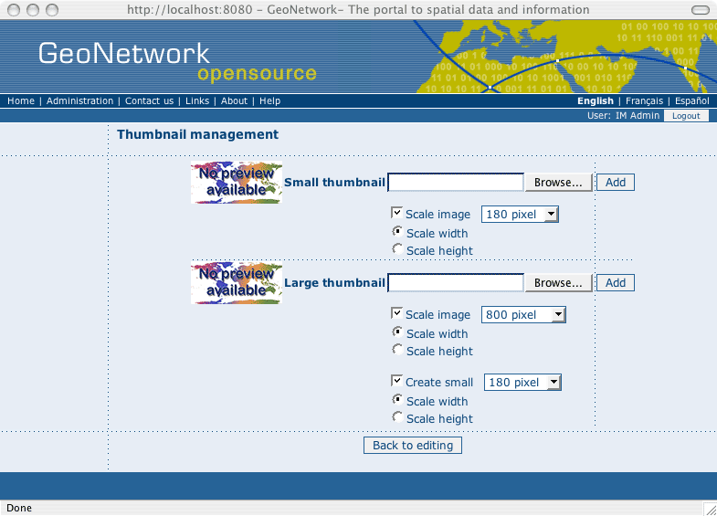
Figure 4.2.3 b
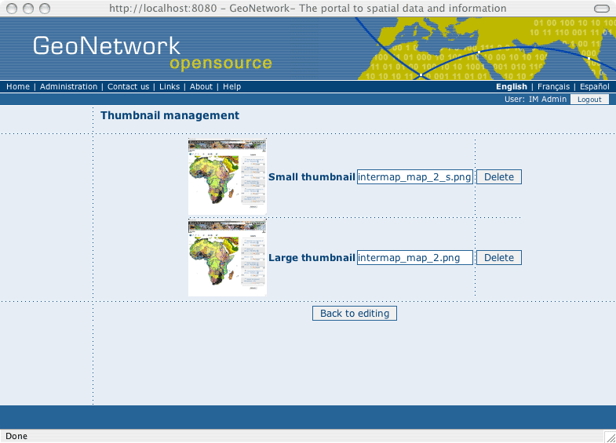
Figure 4.2.3 c

4.2.4 - Assigning Privileges for a Map
As an important step of entering metadata to your map, you need to assign privileges for each map. This means that you will identify which work groups have what privileges, i.e. view, edit, etc. for your particular map.
You can for instance define if the information is visible to All (Internet), or to limit the visibility and related services to internal users only (Intranet). Privileges are assigned on a per group basis. Depending on the User profile (Guest, Registered User, Editor, Admin etc.) access to these functions may differ on a per user basis.
To assign privileges for your map, follow these steps:
- Find your map by using the search option. Whether you have multiple results for search or you pull up the map by itself, you will always see a row of buttons including a Privileges button either on top of the individual record or next to the record. (See figure 4.2.4 a)
Figure 4.2.4 a
- Click on the Privileges button. This will take you to a new page. You can assign certain privileges to specific groups by selecting or deselecting them from this page. Simply click on the small box next to the privilege to place or remove a checkmark. (See figure 4.2.4 b)
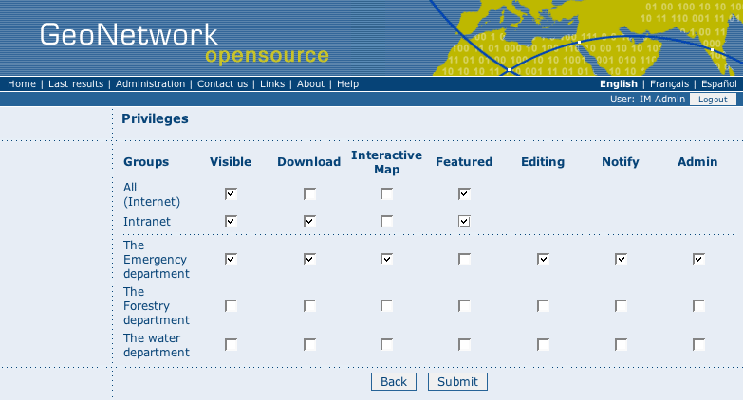
Figure 4.2.4 b
Below is a brief description for each privilege to help you identify which ones you should assign to which group(s).
Visible: Users in that group are able to see the map, i.e. if he/she does a search with matching criteria.
Download: Users in that group are able to download the map.
Interactive Map: Users in that group are able to get an interactive map. The interactive services have to be created separately using a Web Map Server, which is not part of the GeoNetwork opensource application.
Featured: When selected, the map is placed in the Features Maps of the home page of a particular work group. The featured maps are placed on the home page randomly.
Editing: Users in that work group can edit the map.
Notify: Users in that work group get notification that the map has been uploaded into their work group.
Admin: Users in that work group have admin privileges with full editing privileges for the map. Members of the group with an editor profile or higher can access this function.

4.2.5 - Assigning Categories for a Map
As a final step to entering metadata for a map, you should assign categories for it. The assigned categories will determine the categories the map will display under on the home page. To assign categories for a map, follow these steps:
- Find your map by using the search option. Whether you have multiple results for search or you pull up the map by itself, you will always see a row of buttons including a Categories button either on top of the individual record or next to the record. (See figure 4.2.5 a)
Figure 4.2.5 a
- Click on the Categories button. This will take you to a new page. You can assign one or multiple categories selecting or deselecting them from this page. Simply click on the small box next to the category to place or remove a checkmark. (See figure 4.2.4 b)
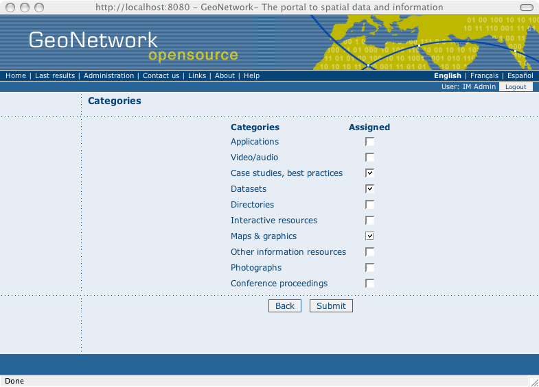Figure 4.2.5 b

Appendix A – Glossary of Data Field Descriptions
This glossary provides you with brief descriptions for all fields in the meta data. Fields that are marked Mandatory are marked with the word Mandatory in red. Note that some mandatory fields are only mandatory if a certain condition is not met.
Access constraints | access constraints applied to assure the protection of privacy or intellectual property, and any special restrictions or limitations on obtaining the resource
Address | location of the responsible individual or organization
Administrative area | state, province of the location
Application profile | name of an application profile that can be used with the online resource
Application schema info | information about the application schema used to build the dataset
Application schema info | provides information about the conceptual schema of a dataset
Page | details on which pages of the publication the article was published
schemaAscii | full application schema given as an ASCII file
Constraint language | formal language used in Application Schema  Mandatory
Graphics file | full application schema given as a graphics file
Name | name of the application schema used  Mandatory
Schema language | identification of the schema language used  Mandatory
Software development file format | software dependent format used for the application schema software dependent file
Software development file | full application schema given as a software development file
Attribute description | description of the attribute described by the measurement value  Mandatory
Attribute instances | attribute instances to which the information applies  Mandatory if attributes, features, feature Instances, dataset and other not documented
Attributes | attributes to which the information applies  Mandatory if features, feature Instances, attribute Instances, dataset and other not documented
Axis dimensions properties | information about spatial-temporal axis properties  Mandatory
Axis units | units of the semi-major axis  Mandatory
Azimuth angle | angle measured clockwise from north, and expressed in degrees  Mandatory
Azimuth measure point longitude | longitude of the map projection origin  Mandatory
Band | range of wavelengths in the electromagnetic spectrum
Begin date | beginning date of the validity period
File description | text description of the illustration
File name | name of the file that contains a graphic that provides an illustration of the dataset  Mandatory
File type | format in which the illustration is encoded
Bits per value | maximum number of significant bits in the uncompressed representation for the value in each band of each pixel
EX_BoundingPolygon | boundary enclosing the dataset, expressed as the closed set of (x y) coordinates of the polygon (last point replicates first point)
MD_BrowseGraphic | graphic that provides an illustration of the dataset (should include a legend for the graphic)
Camera calibration information availability | indication of whether or not constants are available which allow for camera calibration corrections
Feature catalogue citation | complete bibliographic reference to one or more external feature catalogues  Mandatory
Language | language(s) used within the catalogue
Cell geometry | identification of grid data as point or cell  Mandatory
Center point | earth location in the coordinate system defined by the Spatial Reference System and the grid coordinate of the cell halfway between opposite ends of the grid in the spatial dimensions
Check point availability | indication of whether or not geographic position points are available to test the accuracy of the geo referenced grid data  Mandatory
Check point description | description of geographic position points used to test the accuracy of the geo referenced grid data  Mandatory if check Point Availability equals “yes”
CI Citation | standardized resource reference
Identifier | unique identifier for the resource. EXAMPLE: Universal Product Code (UPC), National Stock Number (NSN)
Identifiertype | reference form of the unique identifier (ID). Example: Universal Product Code (UPC), National Stock Number (NSN)
Cited responsible party | name and position information for an individual or organization that is responsible for the resource
City | city of the location
Class | name of the handling restrictions on the resource  Mandatory
Classification system | name of the classification system
Cloud cover percentage | area of the dataset obscured by clouds, expressed as a percentage of the spatial extent
Compression generation quantity | count of the number of compression cycles performed on the image
Address | physical and email address at which the organization or individual may be contacted
Hours of service | time period (including time zone) when individuals can contact the organization or individual
Contact instructions | supplemental instructions on how or when to contact the individual or organization
Phone | telephone numbers at which the organization or individual may be contacted
Collective title | common title with holdings note. NOTE title identifies elements of a series collectively, combined with information about what volumes are available at the source cited
Compliance code | indication of whether or not the cited feature catalogue complies with ISO 19110
Explanation | explanation of the meaning of conformance for this result  Mandatory
Pass | indication of the conformance result where 0 = fail and 1 = pass  Mandatory
Conformance result | Information about the outcome of evaluating the obtained value (or set of values) against a specified acceptable conformance quality level
Specification | citation of product specification or user requirement against which data is being evaluated  Mandatory
Constraints | restrictions on the access and use of a resource or metadata
Content type | type of information represented by the cell value  Mandatory
Content information | description of the content of a dataset
Content info | provides information about the feature catalogue and describes the coverage and image data characteristics
Corner points | earth location in the coordinate system defined by the Spatial Reference System and the grid coordinate of the cells at opposite ends of grid coverage along two diagonals in the grid spatial dimensions. There are four corner points in a geo rectified grid; at least two corner points along one diagonal are required  Mandatory
Country | country of the physical address
Coverage description | information about the content of a grid data cell
Dimension | information on the dimensions of the cell measurement value
Control point availability | indication of whether or not control point(s) exists  Mandatory
Character set | full name of the character coding standard used for the dataset  Mandatory if ISO/IEC 10646-1 not used
Extent | additional extent information including the bounding polygon, vertical, and temporal extent of the dataset  Mandatory if hierarchy Level equals “dataset” either extent geographic Element.EX Geographic Bounding Box or extent geographic Element EX Geographic Description is required
Data identification | information required to identify a dataset
Identification info | basic information about the resource(s) to which the metadata applies  Mandatory
Language | language(s) used within the dataset  Mandatory
Lineage | non-quantitative quality information about the lineage of the data specified by the scope  Mandatory if report not provided
Data quality | quality information for the data specified by a data quality scope
Spatial resolution | factor which provides a general understanding of the density of spatial data in the dataset
Series | information about the series, or aggregate dataset, of which the dataset is a part
Series | information about the series, or aggregate dataset, to which a dataset belongs
Dataset Set | dataset to which the information applies  Mandatory if attributes, features, feature Instances, attribute Instances, and other not documented
Source | information about the source data used in creating the data specified by the scope  Mandatory if mandatory if statement and process Step not provided
Date of next update | scheduled revision date for resource (YYYY-MM-DD)
Date | reference date and event used to describe it (YYYY-MM-DD)
Datum | Identity of the datum used
Delivery point | address line for the location (as described in ISO 11180, annex A)
Denominator of flattening ratio | ratio of the difference between the equatorial and polar radii of the ellipsoid to the equatorial radius when the numerator is set to 1  Mandatory if not a spheroid
Descriptive keywords | provides category keywords, their type, and reference source
Digital transfer options | technical means and media by which a resource is obtained from the distributor
Descriptor | description of the range of a cell measurement value
Dimension | axis properties
Dimension name | name of the axis  Mandatory
Resolution | degree of detail in the grid dataset
Dimension size | number of elements along the axis  Mandatory
Distribution info | provides information about the distributor of and options for obtaining the resource(s)
Distributor contact | party from whom the resource may be obtained. This list need not be exhaustive  Mandatory
Distributor format | provides information about the format used by the distributor  Mandatory if MD Distribution Format not documented
Distribution order process | provides information about how the resource may be obtained, and related instructions and fee information
Distribution | information about the distributor of and options for obtaining the resource
Distributor | information about the distributor
Distributor | provides information about the distributor
Transfer options | provides information about technical means and media by which a resource is obtained from the distributor
Absolute external positional accuracy | closeness of reported coordinate values to values accepted as or being true
Accuracy of time measurement | correctness of the temporal references of an item (reporting of error in time measurement)
Completeness commission | excess data present in the dataset, as described by the scope
Completeness omission | data absent from the dataset, as described by the scope
Conceptual consistency | adherence to rules of the conceptual schema
Domain consistency | adherence of values to the value domains
Format consistency | degree to which data is stored in accordance with the physical structure of the dataset, as described by the scope
Gridded data positional accuracy | closeness of gridded data position values to values accepted as or being true
Data quality info | provides overall assessment of quality of a resource(s)
Non quantitative attribute accuracy | correctness of non-quantitative attributes
Quantitative attribute accuracy | accuracy of quantitative attributes
Relative internal positional accuracy | closeness of the relative positions of features in the scope to their respective relative positions accepted as or being true
Report | quantitative quality information for the data specified by the scope  Mandatory if lineage not provided
Scope | description of the data specified by the scope  Mandatory
Scope | the specific data to which the data quality information applies
Temporal consistency | correctness of ordered events or sequences, if reported
Temporal validity | validity of data specified by the scope with respect to time
Thematic classification correctness | comparison of the classes assigned to features or their attributes to a universe of discourse
Topological consistency | correctness of the explicitly encoded topological characteristics of the dataset as described by the scope
Resource format | provides a description of the format of the resource(s)
East bound longitude | eastern-most coordinate of the limit of the dataset extent, expressed in longitude in decimal degrees (positive east)  Mandatory
Ellipsoid | identity of the ellipsoid used
Ellipsoid parameters | set of parameters that describe the ellipsoid
Ellipsoid parameters | set of parameters that describe the ellipsoid
Electronic mail address | address of the electronic mailbox of the responsible organization or individual
End date | ending date of the validity period
Environment description | description of the dataset in the producers processing environment, including items such as the software, the computer operating system, file name, and the dataset size
Equivalent scale | level of detail expressed as the scale of a comparable hardcopy map or chart  Mandatory if distance not documented
Error statistic | statistical method used to determine the value
Evaluation method description | description of the evaluation method
Evaluation method type code | type of method used to evaluate quality of the dataset
Description | spatial and temporal extent for the referring object  Mandatory if geographic Element and temporal Element and vertical Element not documented
Spatial extent | spatial extent component of composite spatial and temporal extent  Mandatory
Condition | condition under which the extended element is mandatory
Definition | definition of the extended element  Mandatory
Domain value | valid values that can be assigned to the extended element
Extended element information | new metadata element, not found in ISO 19115, which is required to describe geographic data
Extended element information | provides information about a new metadata element, not found in ISO 19115, which is required to describe geographic data
Maximum occurrence | maximum occurrence of the extended element
Name | name of the extended metadata element  Mandatory
Obligation | obligation of the extended element
Parent entity | name of the metadata entity(s) under which this extended metadata element may appear. The name(s) may be standard metadata element(s) or other extended metadata element(s).  Mandatory
Rationale | reason for creating the extended element
Rule | specifies how the extended element relates to other existing elements and entities  Mandatory
Source | name of the person or organization creating the extended element  Mandatory
Extent | date and time for the content of the dataset  Mandatory
Extent | information about spatial, vertical, and temporal extent
Extension Online resource | information about on-line sources containing the community profile name and the extended metadata elements. Information for all new metadata elements
Short name | short form suitable for use in an implementation method such as XML or SGML. NOTE other methods may be used
Extent type code | indication of whether the bounding polygon encompasses an area covered by the data or an area where data is not present
False easting | value added to all _x_ values in the rectangular coordinates for a map projection. This value frequently is assigned to eliminate negative numbers. Expressed in the unit of measure identified in Planar Coordinate Units
False easting northing units | units of false northing and false easting
False northing | value added to all _y_ values in the rectangular coordinates for a map projection. This value frequently is assigned to eliminate negative numbers. Expressed in the unit of measure identified in Planar Coordinate Units
Facsimile | telephone number of a facsimile machine for the responsible organization or individual
Feature instances | feature instances to which the information applies  Mandatory if attributes, features, attribute Instances, dataset and other not documented
Features | features to which the information applies  Mandatory if attributes, feature Instances, attribute Instances, dataset and other not documented
The feature type list | provides information about the list of feature types with the same spatial representation
Feature type list | list of names of feature types with the same spatial representation (same as spatial attributes)
Feature catalogue description | information identifying the feature catalogue
File decompression technique | recommendations of algorithms or processes that can be applied to read or expand resources to which compression techniques have been applied
Film distortion information availability | indication of whether or not Calibration information is available
Format | description of the computer language construct that specifies the representation of data objects in a record, file, message, storage device or transmission channel
Amendment number | amendment number of the format version
Name | name of the data transfer format(s)  Mandatory
Specification | name of a subset, profile, or product specification of the format
Version | version of the format (date, number, etc.)  Mandatory
Geographic bounding box | geographic position of the dataset
Geographic box | minimum bounding rectangle within which data is available  Mandatory if if hierarchy level equals 'dataset' and geo description is not documented
Geographic description | description of the geographic area within which data is available  Mandatory if if hierarchy level equals 'dataset' and geo Box is not documented
Geographic description | Description of the geographic area using identifiers
Geographic element | provides geographic component of the extent of the referring object  Mandatory if description and temporal Element and vertical Element not documented
Geographic identifier | identifier used to represent a geographic area  Mandatory
Geometric objects | information about the geometric objects used in the dataset
Geometric objects | number of objects, listed by geometric object type, used in the dataset
Geometric object count | total number of the point or vector object type occurring in the dataset
Geometric object type | name of point and vector spatial objects used to locate zero-, one-, and two-dimensional spatial locations in the dataset  Mandatory
Geo rectified | grid whose cells are regularly spaced in a geographic (i.e., lat / long) or map coordinate system defined in the Spatial Referencing System (SRS) so that any cell in the grid can be geo located given its grid coordinate and the grid origin, cell spacing, and orientation
Geo referenceable | grid with cells irregularly spaced in any given geographic/map projection coordinate system, whose individual cells can be geo located using geo location information supplied with the data but cannot be geo located from the grid properties alone
Geo referenced parameters | terms which support grid data geo referencing - Mandatory
Graphic overview | provides a graphic that illustrates the resource(s) (should include a legend for the graphic)
Grid spatial representation | information about grid spatial objects in the dataset
Handling description | additional information about the restrictions on handling the resource
Height of prospective point above surface | height of viewpoint above the Earth, expressed in meters
Abstract | brief narrative summary of the content of the resource(s)  Mandatory
Citation | citation data for the resource(s)
Credit | recognition of those who contributed to the resource(s)
Authority | person or party responsible for maintenance of the namespace
Code | alphanumeric value identifying an instance in the namespace  Mandatory
Point of contact | identification of, and means of communication with, person(s) and organizations(s) associated with the resource(s)
Purpose | summary of the intentions with which the resource(s) was developed
Resource specific usage | provides basic information about specific application(s) for which the resource(s) has/have been or is being used by different users
Illumination azimuth angle | illumination azimuth measured in degrees clockwise from true north at the time the image is taken. For images from a scanning device, refer to the centre pixel of the image
Illumination elevation angle | illumination elevation measured in degrees clockwise from the target plane at intersection of the optical line of sight with the Earth’s surface. For images from a scanning device, refer to the centre pixel of the image
Imaging condition | conditions affected the image
Image quality code | specifies the image quality
Image description | information about an image’s suitability for use
Included with dataset | indication of whether or not the feature catalogue is included with the dataset  Mandatory
ISBN | international Standard Book Number
Issue identification | information identifying the issue of the series
ISSN | international Standard Serial Number
Type | subject matter used to group similar keywords
Keyword | commonly used word(s) or formalized word(s) or phrase(s) used to describe the subject
Keywords | keywords, their type and reference source
Latitude of projection center | latitude of the point of projection for azimuthal projections
Latitude of projection origin | latitude chosen as the origin of rectangular coordinates for a map projection
Legal constraints | restrictions and legal prerequisites for accessing and using the resource
Lens distortion information availability | indication of whether or not lens aberration correction information is available
Lineage | information about the events or source data used in constructing the data specified by the scope or lack of knowledge about lineage
Linkage | location (address) for on-line access using a Uniform Resource Locator address or similar addressing scheme such as http://www.statkart.no/isotc211  Mandatory
Longitude of central meridian | line of longitude at the centre of a map projection generally used as the basis for constructing the projection
Longitude of projection center | longitude of the point of projection for azimuthal projections
Maintenance and update frequency | frequency with which changes and additions are made to the resource after the initial resource is completed  Mandatory
Maintenance information | information about the scope and frequency of updating
Maintenance note | information regarding specific requirements for maintaining the resource
Update scope | scope of data to which maintenance is applied
Maximum value | longest wavelength that the sensor is capable of collecting within a designated band
Character set | full name of the character coding standard used for the metadata set  Mandatory if ISO/IEC 10646-1 not used and not defined by encoding
Metadata constraints | provides restrictions on the access and use of data
Metadata author | party responsible for the metadata information  Mandatory
Coordinate reference system | metadata about a coordinate system in which attributes have been derived from SC_CRS as defined in ISO 19111 _ Spatial referencing by coordinates
Date stamp | date that the metadata was created (YYYY-MM-DDT hh:mm:ss)  Mandatory
Metadata extension info | information describing metadata extensions
Metadata extension info | information describing metadata extensions
File identifier | unique identifier for this metadata file
Hierarchy level | scope to which the metadata applies (see annex H for more information about metadata hierarchy levels)
Hierarchy level name | name of the hierarchy levels for which the metadata is provided
Identifier | value uniquely identifying an object within a namespace
Language | language used for documenting metadata  Mandatory if not defined by encoding
Metadata maintenance | provides information about the frequency of metadata updates, and the scope of those updates
Parent identifier | file identifier of the metadata to which this metadata is a subset (child)
Metadata standard name | name of the metadata standard (including profile name) used
Metadata standard version | version (profile) of the metadata standard used
DateTime | date or range of dates on which a data quality measure was applied (YYYY-MM-DDT hh:mm:ss)
Measure identification | code identifying a registered standard procedure
Name of measure | name of the test applied to the data
Result | value (or set of values) obtained from applying a data quality measure or the out come of evaluating the obtained value (or set of values) against a specified acceptable conformance quality level  Mandatory
Density | density at which the data is recorded
Density units | units of measure for the recording density  Mandatory if density documented
Medium format | method used to write to the medium
Medium | information about the media on which the resource can be distributed
Name | name of the medium on which the resource can be received
Medium note | description of other limitations or requirements for using the medium
Volumes | number of items in the media identified
Metadata | root entity which defines metadata about a resource or resources
Minimum value | shortest wavelength that the sensor is capable of collecting within a designated band
North bound latitude | northern-most, coordinate of the limit of the dataset extent expressed in latitude in decimal degrees (positive north)  Mandatory
Number of dimensions | number of independent spatial-temporal axes  Mandatory
Oblique line azimuth | method used to describe the line along which an oblique mercator map projection is centered using the map projection origin and an azimuth
Oblique line latitude | latitude of a point defining the oblique line  Mandatory
Oblique line longitude | longitude of a point defining the oblique line  Mandatory
Oblique line point | method used to describe the line along which an oblique mercator map projection is centered using two points near the limits of the mapped region that define the centre line
Oblique line azimuth parameter | parameters describing the oblique line azimuth
Oblique line point parameter | parameters describing the oblique line point
Offset | the physical value corresponding to a cell value of zero
Online resource | information about on-line sources from which the dataset, specification, or community profile name and extended metadata elements can be obtained
OnLine resource | information about online sources from which the resource can be obtained
Description | detailed text description of what the online resource is/does
Ordering instructions | general instructions, terms and services provided by the distributor
Turnaround | typical turnaround time for the filling of an order
Function | code for function performed by the online resource
Orientation parameter availability | indication of whether or not orientation parameters are available  Mandatory
Name | name of the online resource
Other constraints | other restrictions and legal prerequisites for accessing and using the resource  Mandatory if accessConstraints or useConstraints equal otherRestrictions
Other | class of information that does not fall into the other categories to which the information applies  Mandatory if attributes, features, feature Instances, attribute Instances, and dataset not documented
Other citation details | other information required to complete the citation that is not recorded elsewhere
Parameter citation | reference providing description of the parameters
Peak response | wavelength at which the response is the highest
Planned available datetime | date and time when the dataset will be available (CCYY-MM-DDT hh:mm:ss)
polygon | sets of points defining the bounding polygon  Mandatory
Portrayal catalogue info | provides information about the catalogue of rules defined for the portrayal of a resource(s)
Portrayal catalogue citation | bibliographic reference to the portrayal catalogue cited  Mandatory
Portrayal catalogue reference | information identifying the portrayal catalogue used
Postal code | ZIP or other postal code
Process step | information about an event in the creation process for the data specified by the scope
Process step | information about an event in the creation process for the data specified by the scope  Mandatory if mandatory if statement and source not provided
Processing level code | image distributors code that identifies the level of radiometric and geometric processing that has been applied
Presentation form | mode in which the resource is represented
Projection | identity of the projection used
Projection parameters | set of parameters that describe the projection
Projection parameters | set of parameters that describe the projection
Protocol | connection protocol to be used
PointIn pixel | point in a pixel corresponding to the Earth location of the pixel  Mandatory
Quantitative result | Information about the value (or set of values) obtained from applying a data quality measure
Value type | value type for reporting a data quality result
Value unit | value unit for reporting a data quality result  Mandatory
Radiometric calibration data availability | indication of whether or not the radiometric calibration information for generating the radio metrically calibrated standard data product is available
Range dimension | information on the range of each dimension of a cell measurement value
Date | reference date for the cited resource (YYYY-MM-DD)  Mandatory
Date type | event used for reference date  Mandatory
Reference system identifier | name of reference system  Mandatory if MD CRS projection, MD CRS ellipsoid, and MD CRS date not documented
Reference system info | description of the spatial and temporal reference systems used in the dataset
Reference system | information about the reference system.
Representative fraction | derived from Scale where MD Representative Fraction denominator = 1 / Scale measure And Scale target Units = Scale source Units
Alternate title | short name or other language name by which the cited information is known. Example: "DCW" as an alternative title for "Digital Chart of the World
Resource constraints | provides information about constraints which apply to the resource(s)
Edition | version of the cited resource
Edition date | date of the edition (YYYY-MM-DD)
Fees | fees and terms for retrieving the resource. Include monetary units (as specified in ISO 4217)
Resource maintenance | provides information about the frequency of resource updates, and the scope of those updates
Resolution | level of detail expressed as a scale factor or a ground distance
Responsible party | identification of, and means of communication with, person(s) and organizations associated with the dataset
Date | reference date for the cited resource (YYYY-MM-DD)  Mandatory
Title | name by which the cited resource is known  Mandatory
Result | generalization of more specific result classes
Denominator | the number below the line in a vulgar fraction  Mandatory
Role | function performed by the responsible party  Mandatory
Contact info | address of the responsible party
Individual name | name of the responsible person- surname, given name, title separated by a delimiter  Mandatory if organization Name and position Name not documented
Organisation name | name of the responsible organization  Mandatory if individual Name and position Name not documented
Position name | role or position of the responsible person  Mandatory if individual Name and organization Name not documented
Distance | ground sample distance  Mandatory if equivalent Scale not documented
Scale factor | scale factor which has been applied to the cell value
Scale factor at center | ratio between physical distance and corresponding map distance, along the centre line
Scale factor at equat | ratio between physical distance and corresponding map distance, along the equator
Scale factor at projection origin | multiplier for reducing a distance obtained from a map by computation or scaling tot he actual distance at the projection origin
Scope description | description of the class of information covered by the information
Extent | information about the spatial, vertical and temporal extent of the data specified by the scope  Mandatory if
Hierarchy level | hierarchical level of the data specified by the scope  Mandatory
Level description | detailed description about the level of the data specified by the scope  Mandatory if level not equal “dataset” or “series”
Security constraints | handling restrictions imposed on the resource for national security or similar security concerns
Semi major axis | radius of the equatorial axis of the ellipsoid  Mandatory
Sequence identifier | number that uniquely identifies instances of bands of wavelengths on which a sensor operates
Name | name of the series, or aggregate dataset, of which the dataset is a part
Source | information about the source data used in creating the data specified by the scope
South bound latitude | southern-most coordinate of the limit of the dataset extent, expressed in latitude in decimal degrees (positive north)  Mandatory
Spatial attribute supplement | spatial attributes in the application schema for the feature types
Spatial object | instance of a type defined in the spatial schema
Spatial representation info | digital representation of spatial information in the dataset
Spatial representation type | method used to spatially represent geographic information
Spatial schema name | name of the spatial schema used
Spatial temporal extent | extent with respect to date/time and spatial boundaries
Specific usage | brief description of the resource and/or resource series usage  Mandatory
Source citation | recommended reference to be used for the source data
Description | detailed description of the level of the source data  Mandatory if source Extent not provided
Source extent | information about the spatial, vertical and temporal extent of the source data  Mandatory if description not provided
Source reference system | spatial reference system used by the source data
Scale | denominator of the representative fraction on a source map
Source step | information about an event in the creation process for the source data
Standard order process | common ways in which the resource may be obtained or received, and related instructions and fee information
Statement | general explanation of the data producers knowledge about the lineage of a dataset  Mandatory if (DQ DataQuality.scope, DQ Scope.level = “dataset” or “series”)
Status | status of the resource(s)
Date time | date and time or range of date and time on or over which the process step occurred (YYYY-MM-DDT hh:mm:ss)
Description | description of the event, including related parameters or tolerances  Mandatory
Processor | identification of, and means of communication with, person(s) and organization(s) associated with the process step
Rationale | requirement or purpose for the process step
Source | information about the source data used in creating the data specified by the scope
Straight vertical longitude from pole | longitude to be oriented straight up from the North or South Pole
Supplemental Information | any other descriptive information about the dataset
Telephone | telephone numbers for contacting the responsible individual or organization
Temporal element | provides temporal component of the extent of the referring object  Mandatory if description and geographic Element and vertical Element not documented
Temporal Extent | time period covered by the content of the dataset
Thesaurus name | name of the formally registered thesaurus or a similar authoritative source of keywords
Tone gradation | number of discrete numerical values in the grid data
Topology level | code which identifies the degree of complexity of the spatial relationships
Topic category | main theme(s) of the dataset  Mandatory
Transformation parameter availability | indication of whether or not parameters for transformation exists  Mandatory
Transformation dimension description | description of the information about which grid dimensions are the spatial dimensions
Transformation dimension mapping | information about which grid dimensions are the spatial dimensions
Transfer size | estimated size of a unit in the specified transfer format, expressed in megabytes. The transfer size is > 0.0
Triangulation indicator | indication of whether or not triangulation has been performed upon the image
Units of distribution | tiles, layers, geographic areas, etc., in which data is available
Update scope description | additional information about the range or extent of the resource
Usage | brief description of ways in which the resource(s) is/are currently used
Usage datetime | date and time of the first use or range of uses of the resource and/or resource series (YYYY-MM-DDT hh:mm:ss)
Use constraints | constraints applied to assure the protection of privacy or intellectual property, and any special restrictions or limitations or warnings on using the resource
Use limitation | limitation affecting the fitness for use of the resource. Example, _not to be used for navigation_
User note | explanation of the application of the legal constraints or other restrictions and legal prerequisites for obtaining and using the resource
User contact info | identification of and means of communicating with person(s) and organization(s) using the resource(s)  Mandatory
User defined maintenance frequency | maintenance period other than those defined
User determined limitations | applications, determined by the user for which the resource and/or resource series is not suitable
Value unit | units in which sensor wavelengths are expressed
Vector spatial representation | information about the vector spatial objects in the dataset
Vertical datum | provides information about the origin from which the maximum and minimum elevation values are measured  Mandatory
Vertical element | provides vertical component of the extent of the referring object  Mandatory if description and geographic Element and temporal Element not documented
Vertical extent | vertical domain of dataset
Maximum value | highest vertical extent contained in the dataset  Mandatory
Minimum value | lowest vertical extent contained in the dataset  Mandatory
Vertical Unit of measure | vertical units used for vertical extent information. Examples: meters, feet, millimeters, hector-Pascal  Mandatory
Voice | telephone number by which individuals can speak to the responsible organization or individual
West bound longitude | western-most coordinate of the limit of the dataset extent, expressed in longitude in decimal degrees (positive east)  Mandatory
Zone | unique identifier for 100,000 meter grid zone

